# **Market campaign project**

**Data source explaining:**

1) Dataset Name: “Marketing_Campaign.csv”

### 2) Context: A response model can provide a significant boost to the efficiency of a marketing campaign by increasing responses or reducing expenses. The objective is to predict who will respond to an offer for a product or service

## **Feature descriptions:**

There are descriptions provided by author.

* AcceptedCmp1 - 1 if customer accepted the offer in the 1st campaign, 0 otherwise
* AcceptedCmp2 - 1 if customer accepted the offer in the 2nd campaign, 0 otherwise
* AcceptedCmp3 - 1 if customer accepted the offer in the 3rd campaign, 0 otherwise
* AcceptedCmp4 - 1 if customer accepted the offer in the 4th campaign, 0 otherwise
* AcceptedCmp5 - 1 if customer accepted the offer in the 5th campaign, 0 otherwise
* Response - 1 if customer accepted the offer in the last campaign, 0 otherwise
* Complain - 1 if customer complained in the last 2 years
* DtCustomer - date of customer’s enrolment with the company
* Education - customer’s level of education
* Marital - customer’s marital status
* Kidhome - number of small children in customer’s household
* Teenhome - number of teenagers in customer’s household
* Income - customer’s yearly household income
* MntFishProducts - amount spent on fish products in the last 2 years
* MntMeatProducts - amount spent on meat products in the last 2 years
* MntFruits - amount spent on fruits products in the last 2 years
* MntSweetProducts - amount spent on sweet products in the last 2 years
* MntWines - amount spent on wine products in the last 2 years
* MntGoldProds - amount spent on gold products in the last 2 years
* NumDealsPurchases - number of purchases made with discount
* NumCatalogPurchases - number of purchases made using catalogue
* NumStorePurchases - number of purchases made directly in stores
* NumWebPurchases - number of purchases made through company’s web site
* NumWebVisitsMonth - number of visits to company’s web site in the last month
* Recency - number of days since the last purchase
* Year_Birth - customer's year of birth

### **Analysis the Amount spend with their age range:**

In the age group **old** persons range above 45 years are maximum spend 1056510 and year range **Adult** 31 to 45 spend amount 254115 and **youth** age range 18 to 30 spend amount 8375.

**Adult:** 254115

**Old:** 1056510

**Youth:** 8375

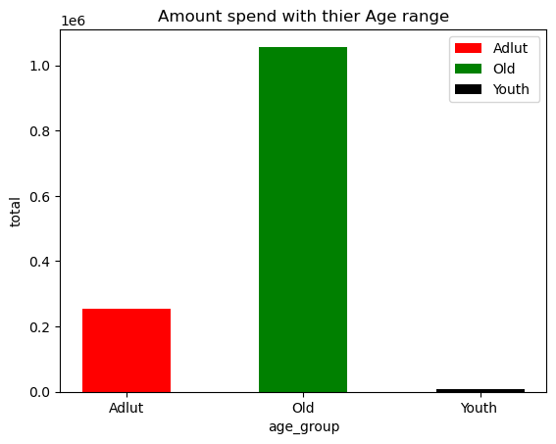

**Analysis by the amount spend with their marital status:**

The **married** persons are spending amount 496524 and 2nd last is **together** is amount spending 343079 and 3rd was **single** persons amount spending 283208 and so on...

**Absurd:** 2038

**Alone:** 710

**Divorced:** 137149

**Married:** 496524

**Single:** 283208

**Together:** 343079

**Widow:** 55522

**YOLO:** 770

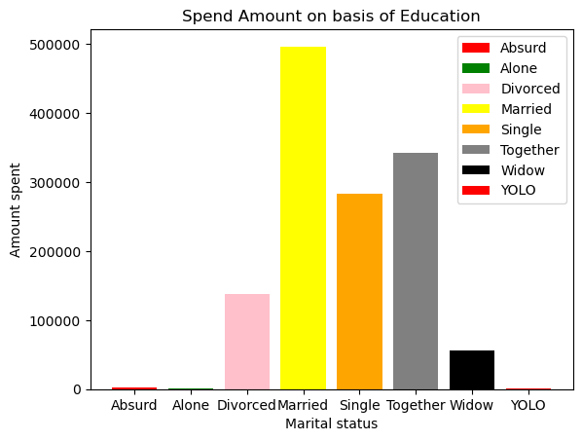

**Analysis the amount spent with their education:**

The **graduation** education is maximum spending amount 676670 and 2nd was **PdD** education persons was spending amount 320916 and 3rd was **master** education spending amount 219247 and **undergraduate** education spending amount 102167.

**Graduation:** 676670

**Master:** 219247

**PhD:** 320916

**Undergraduate:** 102167

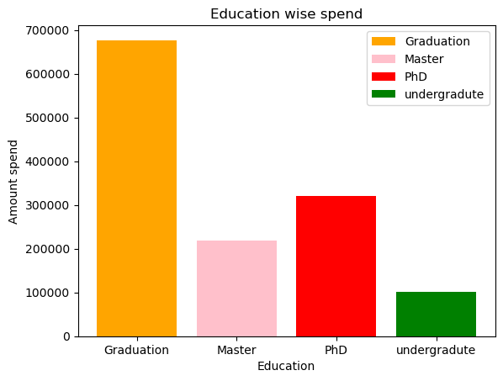

**Analysis the maximum person purchases in discount:**

There is ID are **5376, 8475,238,1501,10749,6862,9931** are maximum purchase in discount in discount period.

**Analysis by the type of purchase mode preferred to customer to purchase:**

Customer maximum preference to **visits the stores** buy the product and 2nd was using **website** customer will preference and 3rd was CatLogpurchase mode preferred and 4th is purchase in **discount period**.

**NumDealsPurchases:** 5208

**NumWebPurchases:** 9150

**NumCatalogPurchases:** 5963

**NumStorePurchases:** 12970

**NumWebVisitsMonth:** 11909

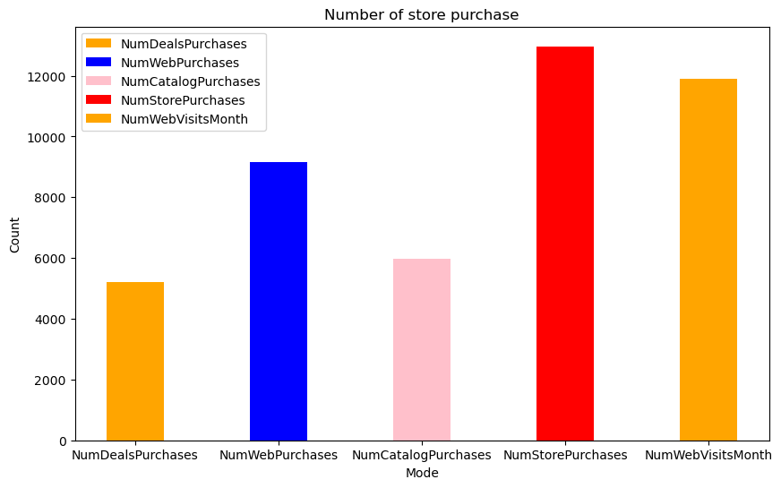

**Analysis by campaign in pie chart:**

In the driven campaign **4th campaign** was most successful campaign and 2nd was successful **3rd campaign** and so on but campaign 2nd was not successful campaign and our trend was going down from campaign 4th

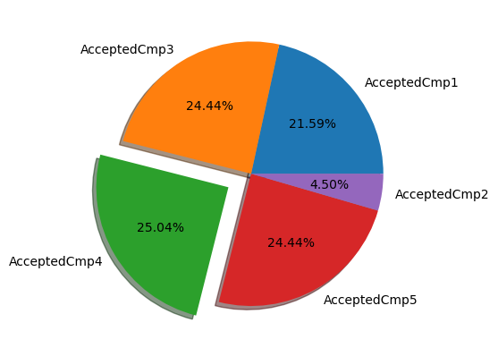

**Analysis by the total amount spending in product and with product wise:**

The **total amount** spending on products 1319000 and most demanded product is **wine** and its purchase around 680816 and **meat** products is also demanded product in market it will purchase around 373968 but **fruits** product is not most demanded in market it purchased in 2 years only 58917.

**MntWines:** 680816

**MntFruits:** 58917

**MntMeatProducts:** 373968

**MntFishProducts:** 84057

**MntSweetProducts:** 60621

**MntGoldProds:** 98609

**total_spent:** 1319000

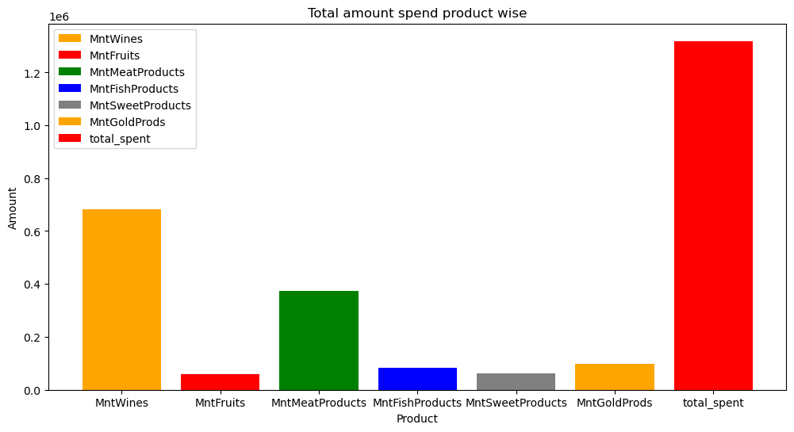

**Analysis the generation complain about the products:**

In the given marketing campaign **old generation** is 15 complains about the product also **Adults** 5 complains about the product

**Adult: 5**

**Old: 15**

**Youth: 1**

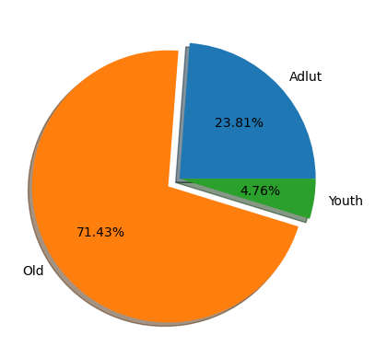

**Analysis by year customer has join our campaign:**

In the year **2013** customer 1189 join our campaign and in the **2014** join 557 person our campaign and so on...

**2013:** 1189

**2014:** 557

**2012:** 494

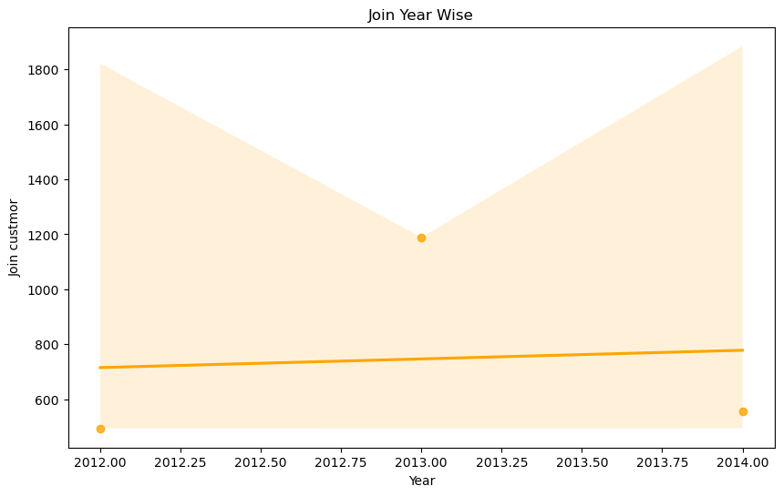

**Analysis the who has most purchase kids’ family or teen family:**

The **teens** family has maximum purchased product and its amount is 530201 and **kids’** family purchased product and its amount is 178933.Teens are purchased greater than kids of amount 351268.

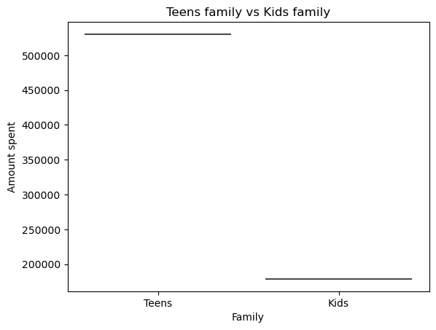

**Analysis by product is demanded in market in old age:**

The old age persons maximum preferred **wine product** and its purchase was 564947 and also preferred **meat product** and its sale was 287911 and so on. But old age not preferred to fruits and sweets products its sale in 2 years only amount of 44906 and 46884.

**MntWines:** 564947

**MntFruits:** 44904

**MntMeatProducts:** 287911

**MntFishProducts:** 64980

**MntSweetProducts:** 46884

**MntGoldProds:** 78308

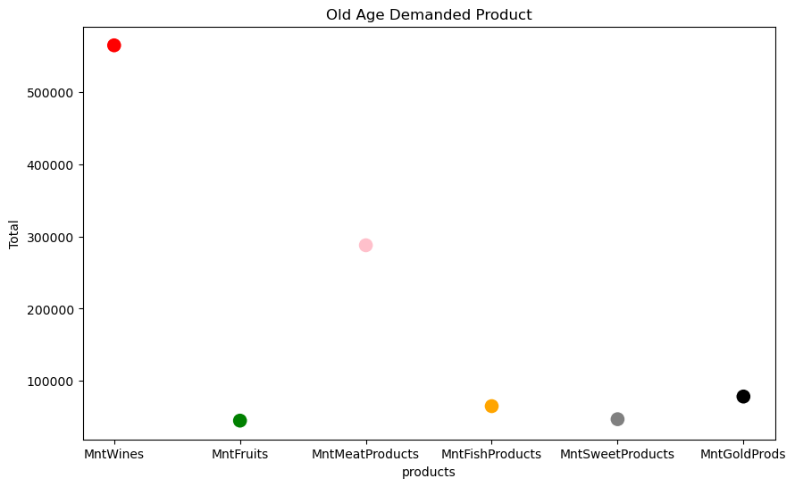

**Analysis the customer who has maximum purchase:**

In this analysis we have define purchase is more than amount 800 in 2 years and selected highest 500 persons bought product

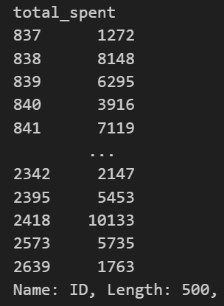

**Analysis the customer has not bought product in the last 20 days:**

In given data we have set criteria of 20 days who have not purchased and we have total 1763 customer has not bought in the last 20 days. Its huge customer base not buy the product. We have mentioned this ID of customer below. Give the discount offer to this customer on store purchase it will increase our sale & revenue.

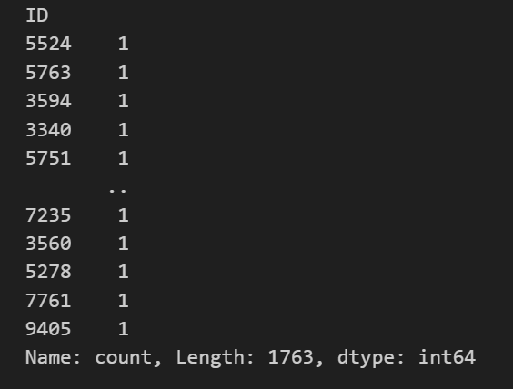

**Analysis by generation and marital is buying gold product:**

We found that in the **married** status **old** age person are buying maximum gold product of amount 29596 and in **together** status **old** age persons is buying the gold product of amount 20117. The **divorced** status **old** age persons are buying gold product of amount 9880 and in single status old age persons are purchased product of amount 14036.In all marital status we found that adult persons are shown much interest to purchasing gold product exception married and single status adult person.

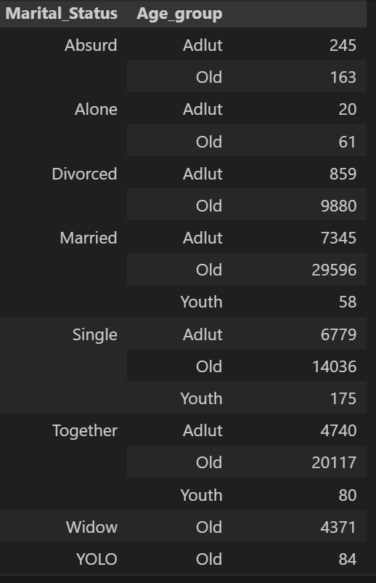

**Analysis the customer is directly come to store for purchasing and how much amount spend:**

We have found that 2240 customer will preferred to purchasing in stored and maximum total spent customer will preferred to visits stores all over the purchasing mode like CatLog, website etc.

